BIT 4107 – Mobile Application Development
STUDENT PROJECT LOGBOOK
Project: SpareDash – Spare Parts Delivery and Management App

Student Name: | NEWTON KARIITHI
Admission Number: | BIT/2025/31318
School / Faculty: | SCHOOL OF COMPUTING AND INFORMATICS
Programme: | BACHELOR OF SSCIENCE IN IFORMATION TECHNOLOGY (BS IT)
Academic Year: | 2025/ 2026
Semester:
Lecturer: | MR MICHAEL NYORO
Phone Number:

Development Platform: Android Studio Language: Kotlin Year: 2026

INSTRUCTIONS
This logbook documents all weekly practical activities undertaken during the development of SpareDash, a native Android mobile application for spare parts delivery and management.

General Rules:
- Complete all sections every week without fail.
- Replace every screenshot placeholder with your actual screenshot from your device or screen.
- Personal reflections must not exceed 50 words.
- This logbook must be submitted together with your final project.
- AI-generated content without practical evidence and screenshots will not be accepted.
- All screenshots must be from your own machine, emulator, or connected Android device.

Note on Device Testing:
SpareDash is developed and tested using a real Android device connected via USB cable. USB Debugging must be enabled on the device. Screenshots should be taken from the device screen directly or using Android Studio screen capture.

WEEK 1: Introduction to Mobile Application Development

Practical Activities Undertaken
- Downloaded and installed Android Studio (latest stable version) on development machine.
- Completed Android Studio initial setup wizard including SDK download.
- Installed Android SDK: API 24 (minimum) and API 34 (target).
- Enabled Developer Options on Android phone by tapping Build Number 7 times.
- Enabled USB Debugging on Android phone under Developer Options.
- Connected Android phone to laptop via USB cable and confirmed device detected in Android Studio.
- Studied the mobile application ecosystem: Android vs iOS vs Cross-platform development.
- Installed Git and configured username and email for version control.
- Created GitHub account and repository named SpareDash.

Screenshots / Evidence
Screenshots Attached: Yes / No (circle one)

Screenshot: Android Studio installation complete screen
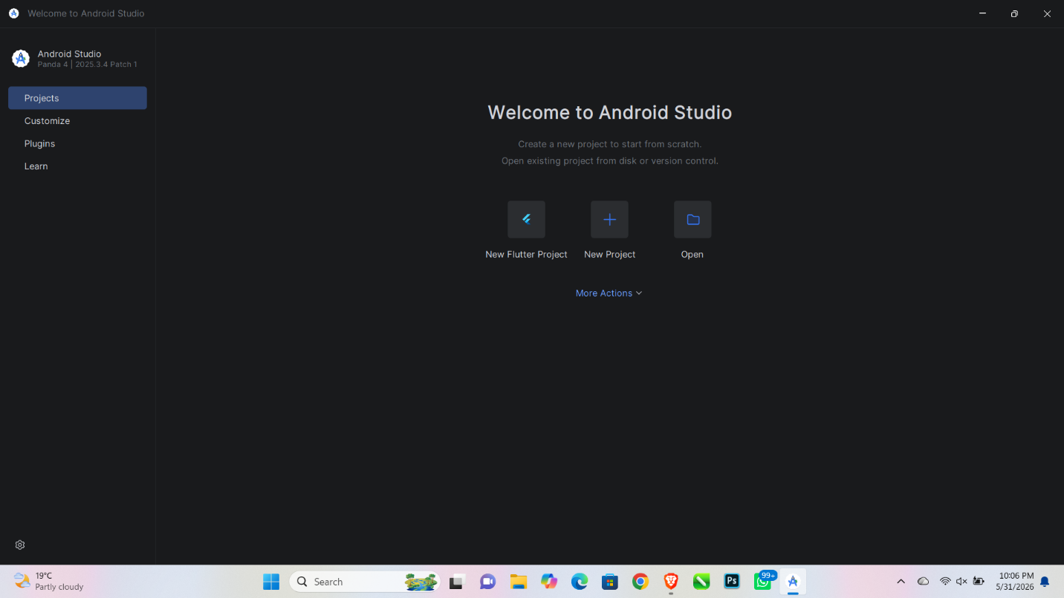

Screenshot: Android SDK Manager showing API 24 and API 34 installed
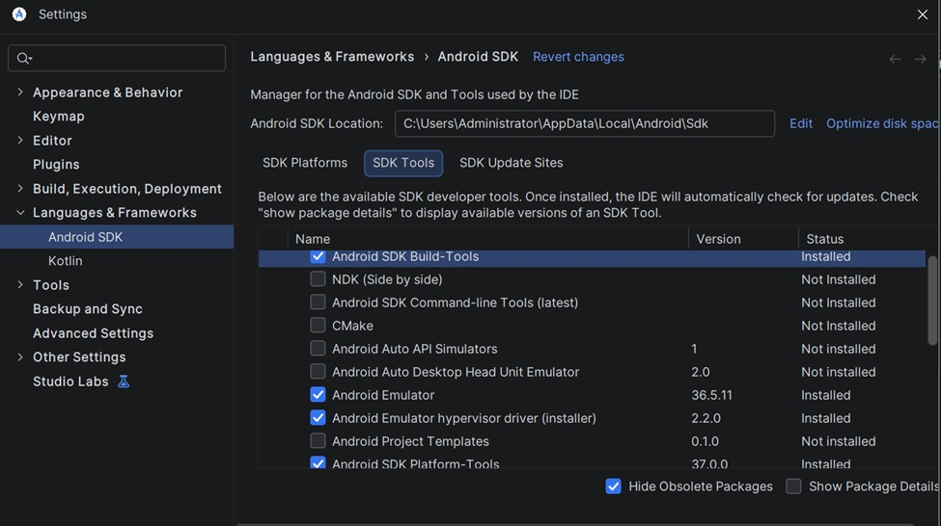

Screenshot: Android phone connected and visible in Android Studio device list
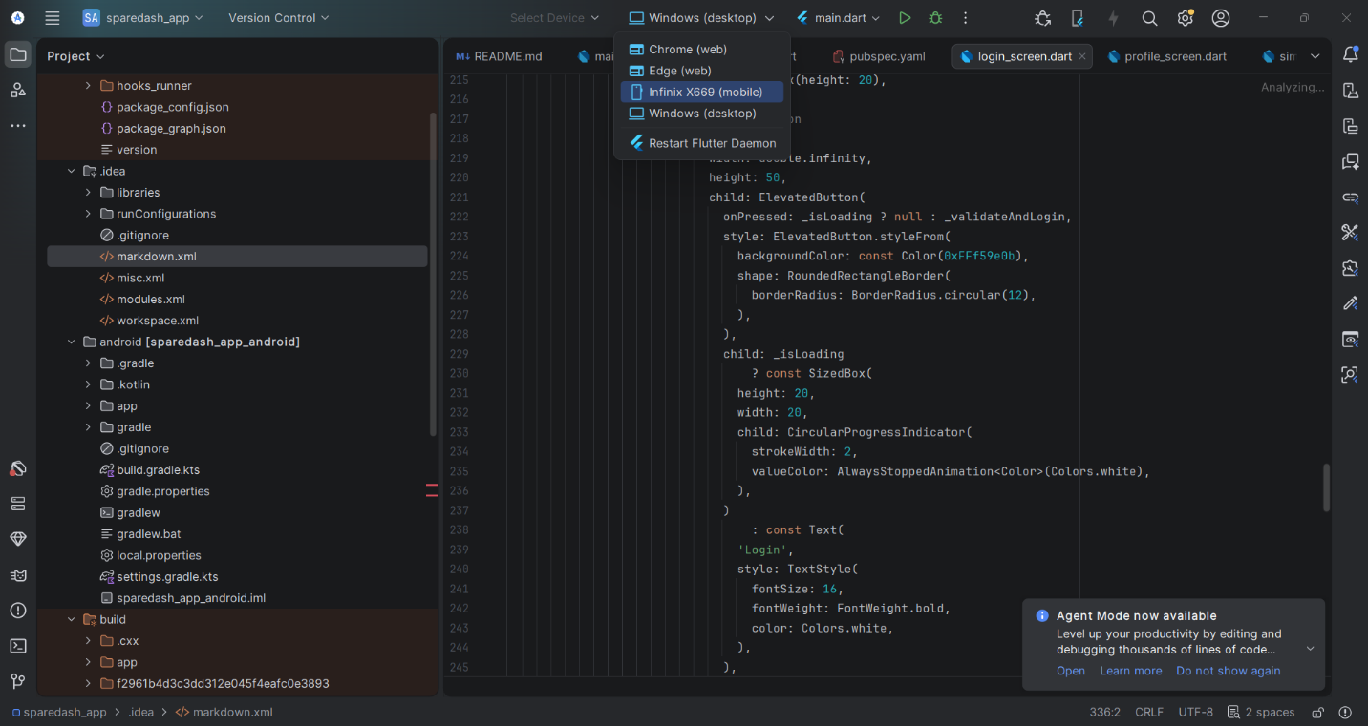

Screenshot: USB Debugging enabled in phone Developer Options
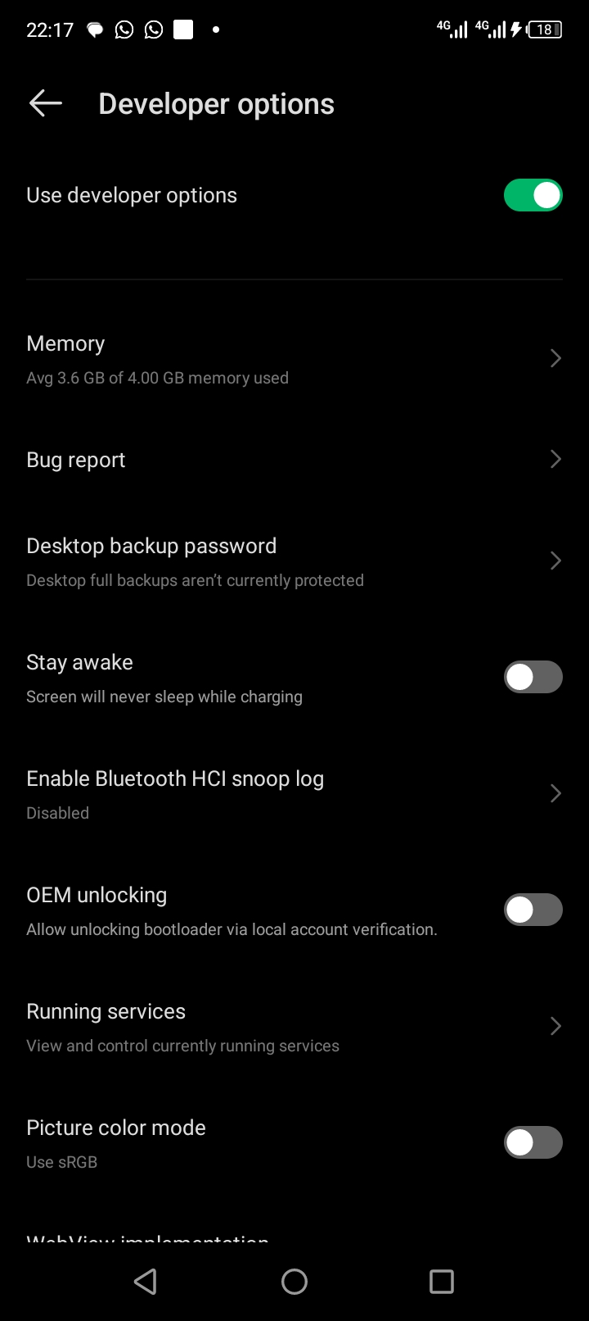

Screenshot: GitHub repository named SpareDash created

Tools / Software Used

Tool / Software | Version / Details | Purpose
Android Studio | Latest Stable 2024+ | Primary development IDE
Android SDK | API 24 and API 34 | Android platform libraries
Git | Latest version | Version control
GitHub | github.com | Remote repository hosting
Android Phone | USB connected | Real device for testing

Personal Reflection
(Not more than 50 words)

WEEK 2: Mobile Development Environment

Practical Activities Undertaken
- Created new Android project: Name = SpareDash, Package = com.sparedash.app, Language = Kotlin, Min SDK = API 24.
- Confirmed Gradle sync completed successfully.
- Explored the generated project folder structure: java/, res/layout/, res/values/, AndroidManifest.xml.
- Added all required Gradle dependencies: Room, Navigation Component, ViewModel, LiveData, Glide, Coroutines, Material Design.
- Created package folders: data/, ui/, viewmodel/, utils/ inside com.sparedash.app.
- Defined app colour scheme in res/values/colors.xml.
- Configured AndroidManifest.xml: app name, theme, INTERNET permission.
- Ran the default Hello World app on the connected Android phone via USB.
- Made first GitHub commit: "Initial commit: SpareDash project setup".

Screenshots / Evidence
Screenshots Attached: Yes / No (circle one)

Screenshot: SpareDash project open in Android Studio showing folder structure
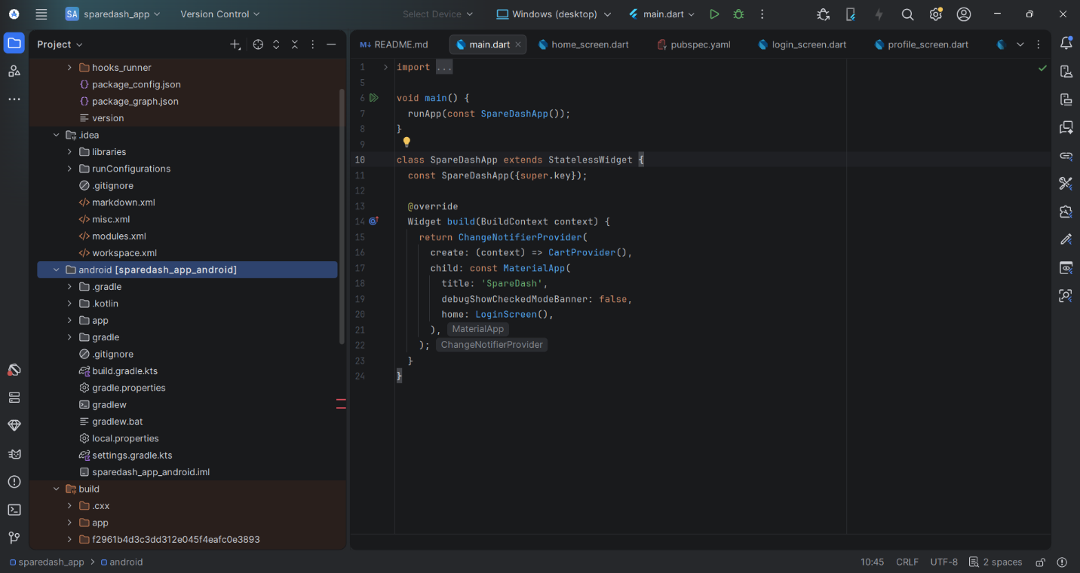

Screenshot: build.gradle.kts showing all dependencies added
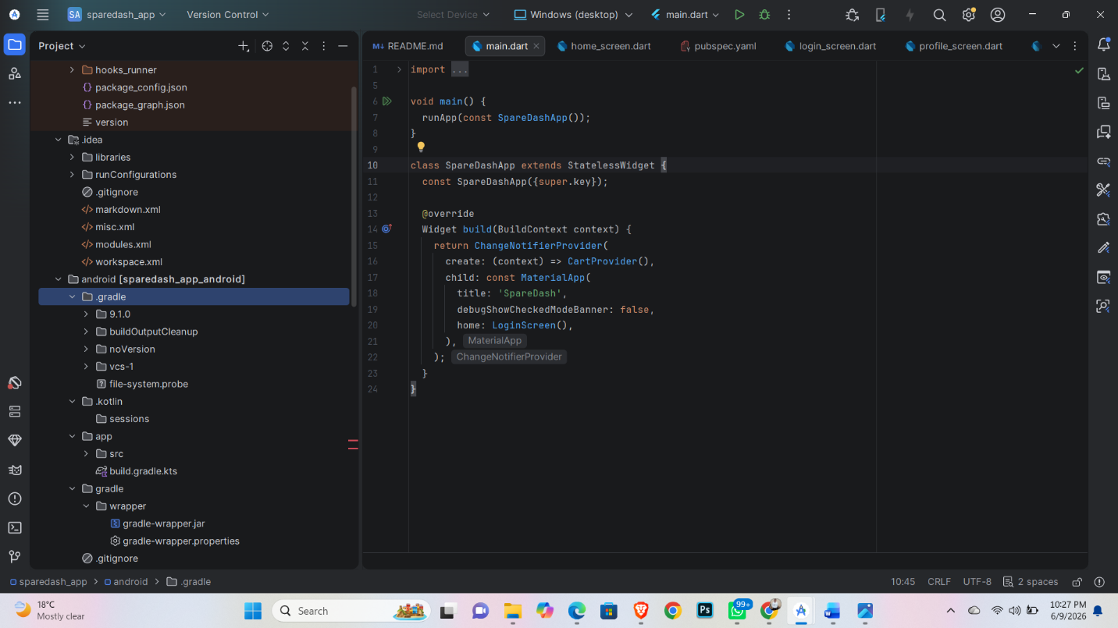

Screenshot: Default app running on real Android phone (USB)
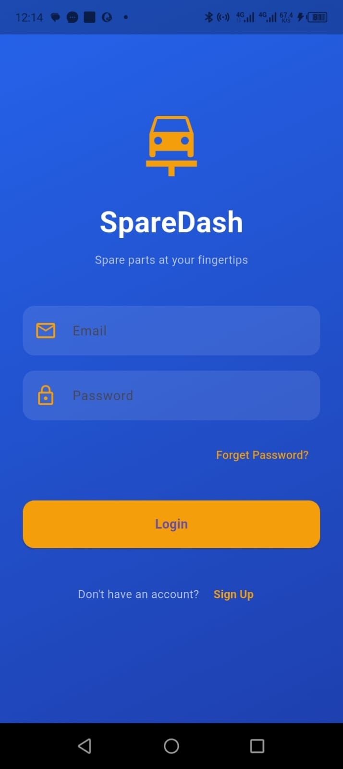

Screenshot: GitHub showing first commit
[Paste your screenshot here]

Tools / Software Used

Tool / Software | Version / Details | Purpose
Android Studio | Latest Stable | Project creation and coding
Gradle (Kotlin DSL) | build.gradle.kts | Build and dependency management
Material Design 3 | 1.11.0 | UI component library
Room Library | 2.6.1 | Local SQLite database
GitHub | github.com | Version control and portfolio
Android Phone via USB | — | Running app on real device

Personal Reflection
(Not more than 50 words)

WEEK 3: User Interface Design

Practical Activities Undertaken
- Designed all 10 SpareDash wireframe screens in Figma: Splash, Login, Register, Home, Parts Catalogue, Part Details, Cart, Order Placement, Order Tracking, Admin Dashboard.
- Applied Material Design 3 principles across all screens.
- Created activity_splash.xml layout: app name centred on plain background.
- Created SplashActivity.kt: 2-second delay then navigates to LoginActivity.
- Created activity_login.xml: email field, password field, login button, register link.
- Created LoginActivity.kt: basic form validation (empty field check).
- Created activity_home.xml: RecyclerView grid for spare parts categories.
- Tested Splash Screen and Login Screen on real Android phone via USB.

Screenshots / Evidence
Screenshots Attached: Yes / No (circle one)

Screenshot: Figma workspace showing all SpareDash wireframe screens
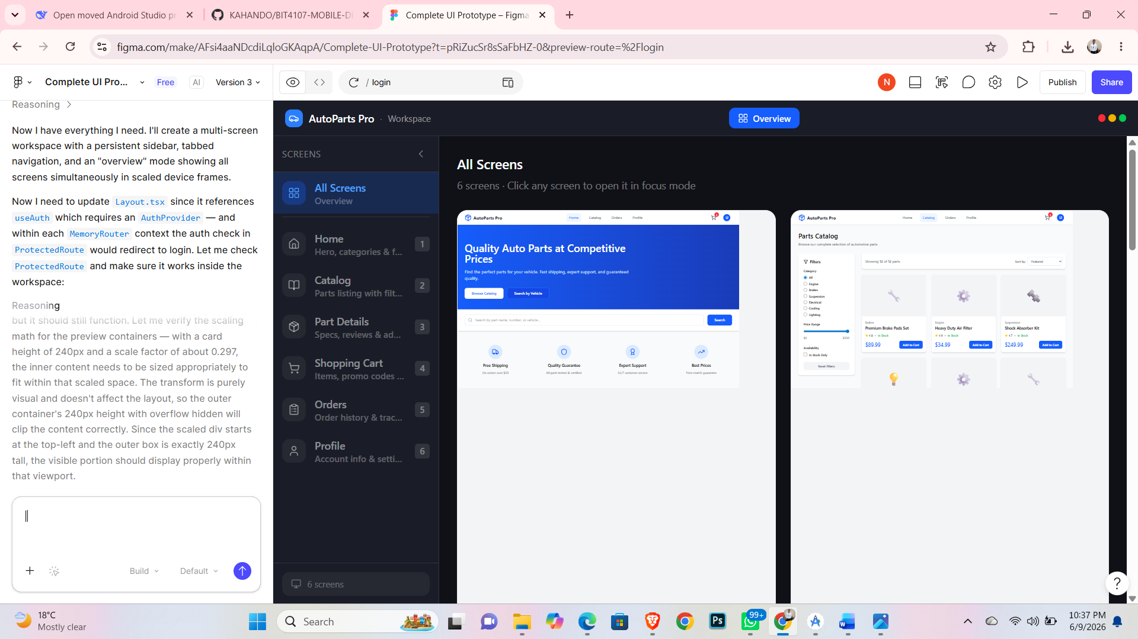

Screenshot: activity_splash.xml open in Android Studio Layout Editor
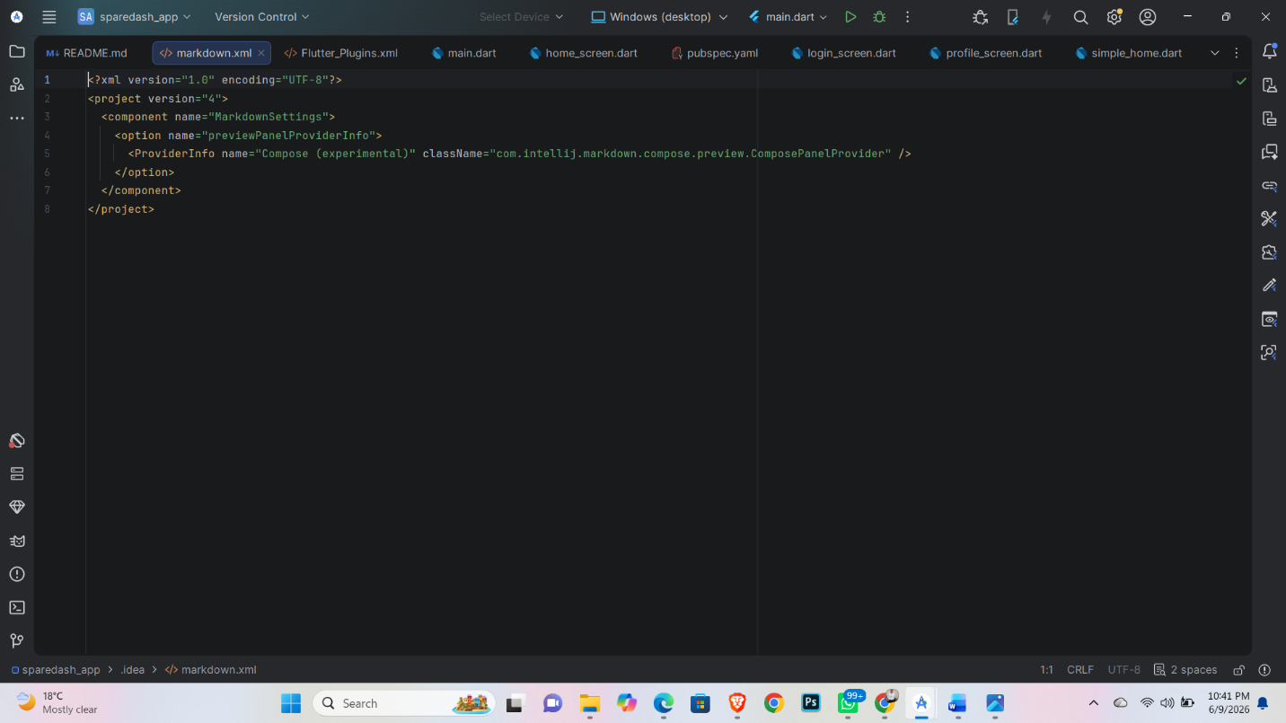

Screenshot: activity_login.xml open in Android Studio Layout Editor
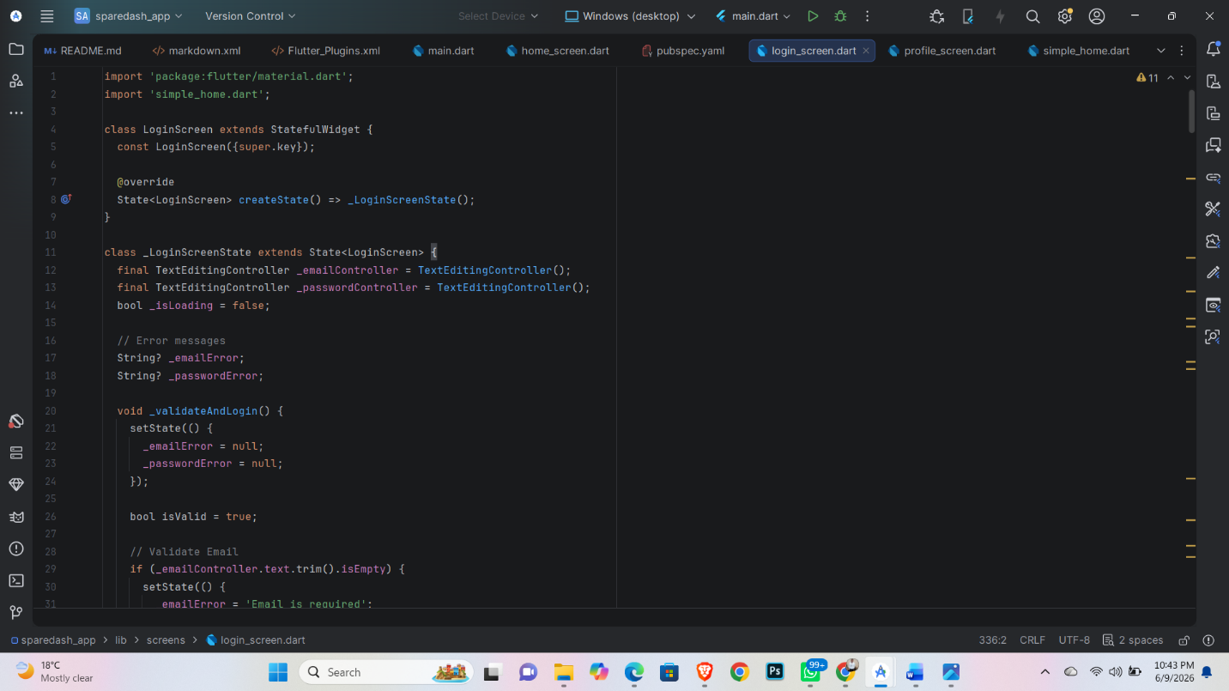

Screenshot: Splash Screen displayed on real Android phone
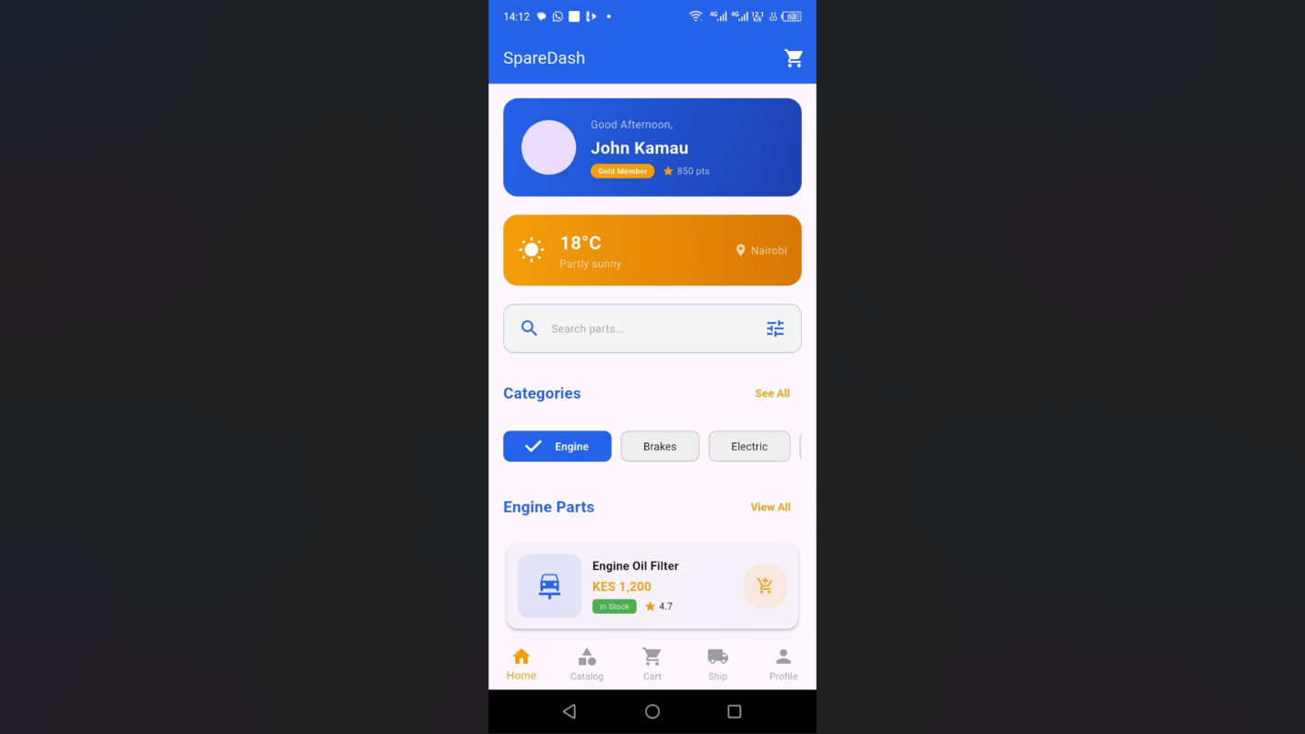

Screenshot: Login Screen displayed on real Android phone


Tools / Software Used

Tool / Software | Version / Details | Purpose
Figma | Web (free plan) | Wireframing and UI design
Android Studio Layout Editor | Built-in | XML layout design
Material Design 3 | Component library | UI design guidelines
ConstraintLayout | AndroidX | Flexible screen layouts
Android Phone via USB | — | Testing screens on real device

Personal Reflection
(Not more than 50 words)

WEEK 4: Event Handling and User Interaction

Practical Activities Undertaken
- Implemented LoginActivity.kt with full form validation: empty fields check and email format check.
- Created RegistrationActivity.kt with input fields: name, email, phone, password, confirm password.
- Added password visibility toggle using TextInputLayout from Material Design.
- Implemented click listeners for: Login button, Register link, and Back navigation.
- Added Toast messages to display validation error feedback to the user.
- Implemented Intent navigation: Login to Home, Login to Register.
- Tested all button interactions and form validation on real Android phone via USB.
- Committed changes to GitHub: "feat: Login and Registration screens with validation".

Screenshots / Evidence
Screenshots Attached: Yes / No (circle one)

Screenshot: LoginActivity.kt code showing click listener and validation logic
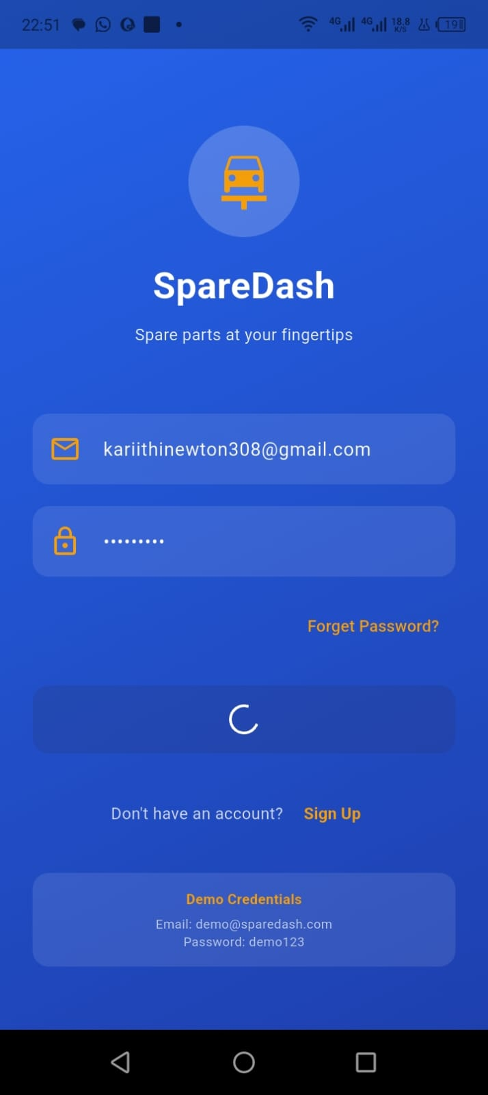

Screenshot: RegistrationActivity.kt code open in Android Studio
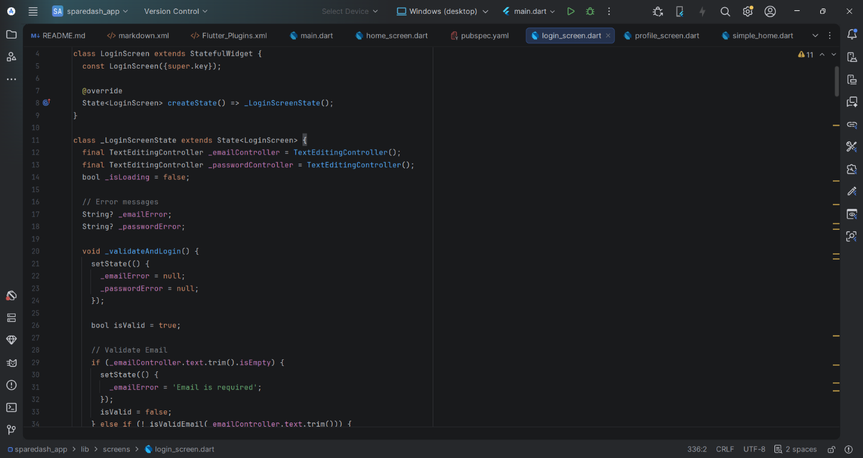

Screenshot: Login Screen on real phone showing validation toast for empty fields
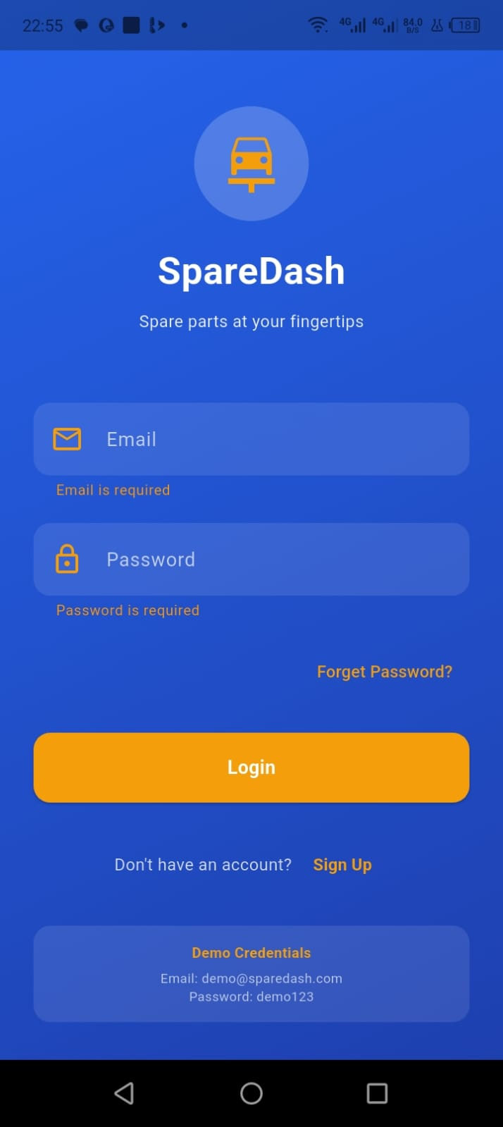

Screenshot: Registration Screen displayed on real Android phone
[Paste your screenshot here]

Screenshot: Successful navigation from Login to Home Screen on real phone
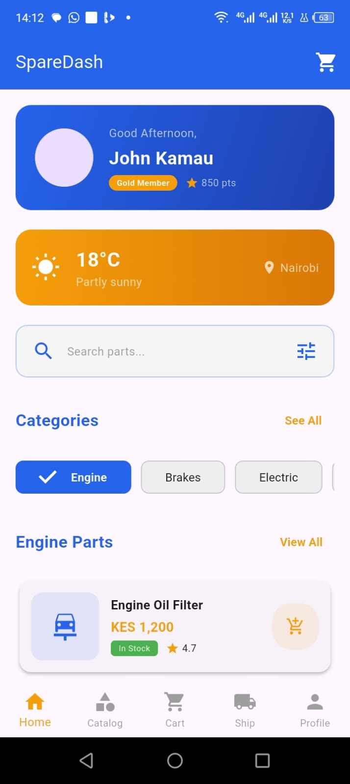

Tools / Software Used

Tool / Software | Version / Details | Purpose
Kotlin setOnClickListener | — | Button and link click handling
TextInputLayout | Material 1.11.0 | Password toggle and styled inputs
Toast | Android SDK | User feedback messages
Intent | Android SDK | Screen-to-screen navigation
Android Phone via USB | — | Testing interactions on real device

Personal Reflection
(Not more than 50 words)

WEEK 5: Data Management

Practical Activities Undertaken
- Created Room Database entity classes: SparePart, Order, User.
- Created DAO interfaces: SparePartDao, OrderDao, UserDao with full CRUD operations.
- Built SpareDashDatabase.kt as a singleton using the companion object pattern.
- Created Repository classes to abstract database access from ViewModels.
- Built SparePartViewModel.kt connected to LiveData for reactive UI updates.
- Populated database with 20 sample spare parts across 6 categories.
- Tested database insert and query operations using Android Studio Debugger and Logcat.
- Verified data displays correctly on Home Screen on real Android phone.
- Committed to GitHub: "feat: Room database entities, DAO, ViewModel".

Screenshots / Evidence
Screenshots Attached: Yes / No (circle one)

Screenshot: SparePart.kt entity class code in Android Studio
[Paste your screenshot here]

Screenshot: SparePartDao.kt showing all query methods
[Paste your screenshot here]

Screenshot: SpareDashDatabase.kt singleton class
[Paste your screenshot here]

Screenshot: SparePartViewModel.kt code
[Paste your screenshot here]

Screenshot: Home Screen on real phone showing spare parts loaded from Room database
[Paste your screenshot here]

Tools / Software Used

Tool / Software | Version / Details | Purpose
Room Persistence Library | 2.6.1 | SQLite database abstraction
LiveData | Lifecycle 2.7.0 | Reactive data observation
ViewModel | Lifecycle 2.7.0 | UI state management
Coroutines | 1.7.3 | Background database operations
Android Studio Logcat | Built-in | Debugging database operations
Android Phone via USB | — | Viewing real data on device

Personal Reflection
(Not more than 50 words)

WEEK 6: Networking and APIs

Practical Activities Undertaken
- Created Firebase project named SpareDash at console.firebase.google.com.
- Added Android app to Firebase with package name com.sparedash.app.
- Downloaded google-services.json and placed inside the app/ folder.
- Added Firebase BOM, Authentication, Firestore, and Messaging dependencies to Gradle.
- Replaced local authentication with Firebase email and password Authentication.
- Implemented Firebase user registration and login in Kotlin.
- Synced spare parts data to Firestore cloud database.
- Added INTERNET permission to AndroidManifest.xml.
- Tested registration and login on real Android phone via USB.

Screenshots / Evidence
Screenshots Attached: Yes / No (circle one)

Screenshot: Firebase Console showing SpareDash project created
[Paste your screenshot here]

Screenshot: google-services.json visible inside app/ folder in Android Studio
[Paste your screenshot here]

Screenshot: Firebase Authentication console showing registered test user
[Paste your screenshot here]

Screenshot: Firestore database showing spare_parts collection with documents
[Paste your screenshot here]

Screenshot: Successful Firebase login on real Android phone
[Paste your screenshot here]

Tools / Software Used

Tool / Software | Version / Details | Purpose
Firebase BOM | 32.7.0 | Firebase dependency management
Firebase Authentication | firebase-auth-ktx | User login and registration
Cloud Firestore | firebase-firestore-ktx | Cloud database
Firebase Messaging | firebase-messaging-ktx | Push notifications
Android Phone via USB | — | Testing Firebase auth on device

Personal Reflection
(Not more than 50 words)

WEEK 7: Application Architecture

Practical Activities Undertaken
- Implemented MVVM architecture across all SpareDash screens.
- Created Bottom Navigation bar with 4 tabs: Home, Parts, Cart, Orders.
- Built Navigation Graph (nav_graph.xml) defining all screen transitions.
- Converted main Activities to Fragments for the navigation flow.
- Implemented RecyclerView with custom SparePartAdapter for the parts list.
- Built Part Details screen: loads part name, price, stock quantity, and Add to Cart button.
- Created Shopping Cart logic: add items, remove items, update quantity, calculate subtotal.
- Tested all navigation and cart functions on real Android phone via USB.
- Committed to GitHub: "feat: MVVM architecture, bottom navigation, cart".

Screenshots / Evidence
Screenshots Attached: Yes / No (circle one)

Screenshot: Navigation Graph (nav_graph.xml) shown visually in Android Studio
[Paste your screenshot here]

Screenshot: Bottom Navigation bar on real Android phone
[Paste your screenshot here]

Screenshot: Parts Catalogue screen showing spare parts list on real phone
[Paste your screenshot here]

Screenshot: Part Details screen on real phone showing part info and Add to Cart button
[Paste your screenshot here]

Screenshot: Shopping Cart screen on real phone showing added items and subtotal
[Paste your screenshot here]

Tools / Software Used

Tool / Software | Version / Details | Purpose
Navigation Component | 2.7.6 | Fragment navigation management
BottomNavigationView | Material 1.11.0 | Tab navigation bar
RecyclerView | AndroidX | Efficient list and grid display
Fragment | AndroidX | Modular UI screens
Android Phone via USB | — | Navigation and cart testing on device

Personal Reflection
(Not more than 50 words)

WEEK 8: Project Planning

Practical Activities Undertaken
- Created Order entity and OrderDao with full CRUD operations.
- Built Order Placement screen: delivery address input and confirm order button.
- Implemented order status flow: Pending, Processing, Dispatched, Delivered.
- Created My Orders screen showing order history with status labels.
- Built Admin Dashboard: view all orders and update order status.
- Linked Shopping Cart to Order creation: items are saved as an order on confirmation.
- Created Trello board to track SpareDash development milestones and tasks.
- Tested full order flow on real Android phone via USB: add to cart, confirm order, view in My Orders.
- Committed to GitHub: "feat: Order management system and admin dashboard".

Screenshots / Evidence
Screenshots Attached: Yes / No (circle one)

Screenshot: Order Placement screen on real Android phone
[Paste your screenshot here]

Screenshot: My Orders screen showing order history with status on real phone
[Paste your screenshot here]

Screenshot: Admin Dashboard on real phone showing orders with status update option
[Paste your screenshot here]

Screenshot: Trello board showing SpareDash project tasks and milestones
[Paste your screenshot here]

Screenshot: GitHub commit history showing weekly progress
[Paste your screenshot here]

Tools / Software Used

Tool / Software | Version / Details | Purpose
Room - Order Entity | 2.6.1 | Store order records in local DB
Firestore Orders Collection | Firebase | Cloud order storage
RecyclerView | AndroidX | Display order history list
Trello | Web | Project milestone and task tracking
Android Phone via USB | — | Order flow testing on real device

Personal Reflection
(Not more than 50 words)

WEEK 9: Device Features and Sensors

Practical Activities Undertaken
- Implemented camera access for profile picture upload using ActivityResultLauncher.
- Added image picker from phone gallery for spare part images in Admin panel.
- Used Glide library to load and cache images in RecyclerView efficiently.
- Implemented real-time search using SearchView with Room database query.
- Added pull-to-refresh using SwipeRefreshLayout on the Parts Catalogue screen.
- Implemented GPS location request for delivery address auto-detection on Order screen.
- Requested runtime permissions on device: CAMERA, READ_MEDIA_IMAGES, ACCESS_FINE_LOCATION.
- Tested all device features on real Android phone via USB.

Screenshots / Evidence
Screenshots Attached: Yes / No (circle one)

Screenshot: Camera or gallery permission dialog appearing on real phone
[Paste your screenshot here]

Screenshot: Profile picture updated and displayed in app on real phone
[Paste your screenshot here]

Screenshot: Search bar on Parts Catalogue filtering results in real time on real phone
[Paste your screenshot here]

Screenshot: Location permission dialog and address auto-fill on Order screen on real phone
[Paste your screenshot here]

Tools / Software Used

Tool / Software | Version / Details | Purpose
ActivityResultLauncher | AndroidX | Camera and gallery access
Glide | 4.16.0 | Image loading and caching
SearchView | Android SDK | Real-time parts search
SwipeRefreshLayout | AndroidX | Pull-to-refresh gesture
FusedLocationProvider | Google Play Services | GPS location for delivery address
Android Phone via USB | — | Device feature testing on real phone

Personal Reflection
(Not more than 50 words)

WEEK 10: Notifications and Background Services

Practical Activities Undertaken
- Set up Firebase Cloud Messaging (FCM) for push notifications.
- Created SpareDashMessagingService.kt extending FirebaseMessagingService.
- Implemented order status push notifications sent to customer when order status changes.
- Built local notifications using NotificationManager and NotificationChannel for API 26 and above.
- Created background WorkManager job to sync Firestore data periodically.
- Tested push notifications by sending test messages from Firebase Console to real phone.
- Confirmed notifications appear in phone notification tray.
- Committed to GitHub: "feat: Push notifications and background sync".

Screenshots / Evidence
Screenshots Attached: Yes / No (circle one)

Screenshot: Firebase Messaging console showing test notification sent
[Paste your screenshot here]

Screenshot: Push notification appearing in notification tray on real Android phone
[Paste your screenshot here]

Screenshot: SpareDashMessagingService.kt code in Android Studio
[Paste your screenshot here]

Screenshot: WorkManager sync job code and Logcat output in Android Studio
[Paste your screenshot here]

Tools / Software Used

Tool / Software | Version / Details | Purpose
Firebase Cloud Messaging | firebase-messaging-ktx | Push notifications
FirebaseMessagingService | FCM | Handle incoming push messages
NotificationManager | Android SDK | Display local notifications
NotificationChannel | Android SDK API 26+ | Required notification channel setup
WorkManager | AndroidX Work | Background sync tasks
Android Phone via USB | — | Receiving and testing notifications on device

Personal Reflection
(Not more than 50 words)

WEEK 11: Mobile Security

Practical Activities Undertaken
- Configured Firebase Firestore Security Rules: users can only access their own data.
- Added input sanitization on all form fields to prevent invalid or malicious input.
- Stored sensitive tokens using Android EncryptedSharedPreferences.
- Added network_security_config.xml to enforce HTTPS connections.
- Implemented session management: user is logged out after 30 minutes of inactivity.
- Added ProGuard rules in release build configuration to obfuscate compiled code.
- Verified Firebase Authentication token validation on all protected operations.
- Tested security features on real Android phone via USB.

Screenshots / Evidence
Screenshots Attached: Yes / No (circle one)

Screenshot: Firebase Firestore Security Rules configuration in Firebase Console
[Paste your screenshot here]

Screenshot: network_security_config.xml file open in Android Studio
[Paste your screenshot here]

Screenshot: EncryptedSharedPreferences implementation code in Android Studio
[Paste your screenshot here]

Screenshot: ProGuard rules file (proguard-rules.pro) in Android Studio
[Paste your screenshot here]

Tools / Software Used

Tool / Software | Version / Details | Purpose
Firebase Security Rules | Firebase Console | Database read and write access control
EncryptedSharedPreferences | AndroidX Security | Secure local storage
Network Security Config | Android SDK | Enforce HTTPS connections
ProGuard / R8 | Build tools | Code obfuscation in release build
Firebase Auth Tokens | Firebase | Secure API authentication

Personal Reflection
(Not more than 50 words)

WEEK 12: Testing and Debugging

Practical Activities Undertaken
- Conducted full testing of all 10 SpareDash screens on real Android phone via USB.
- Used Android Studio Logcat to identify and resolve runtime errors.
- Fixed bug: RecyclerView crashing when database returns an empty list.
- Fixed bug: Cart item quantity not updating correctly after increment or decrement.
- Wrote unit tests for SparePartViewModel using JUnit.
- Wrote instrumented tests for Room DAO using AndroidJUnit4.
- Generated debug APK: app-debug.apk and shared with 3 testers for feedback.
- Documented all test cases and results in the testing table below.
- Committed fixes to GitHub: "fix: RecyclerView empty state and cart quantity bugs".

Screenshots / Evidence
Screenshots Attached: Yes / No (circle one)

Screenshot: All 10 SpareDash screens running on real Android phone
[Paste your screenshot here]

Screenshot: Android Studio Logcat showing debug session and resolved errors
[Paste your screenshot here]

Screenshot: Unit test results showing PASSED in Android Studio
[Paste your screenshot here]

Screenshot: app-debug.apk file in build/outputs/apk/debug/ folder
[Paste your screenshot here]

Tools / Software Used

Tool / Software | Version / Details | Purpose
Android Studio Logcat | Built-in | Runtime debugging and error logs
JUnit | 4.13.2 | Unit testing Kotlin classes
AndroidJUnit4 | AndroidX Test | Instrumented Room database tests
Android Phone via USB | — | Full app testing on real device
Debug APK | Build output | Beta testing distribution to testers

Personal Reflection
(Not more than 50 words)

WEEK 13: Application Deployment

Practical Activities Undertaken
- Generated signed Android App Bundle (AAB) for release.
- Created Keystore file (sparedash.jks) with alias sparedash, validity 25 years.
- Enabled R8 code shrinking and ProGuard obfuscation in release build configuration.
- Prepared Play Store assets: app icon 512x512 PNG, feature graphic 1024x500 PNG.
- Wrote Play Store listing: app title, short description, and full description.
- Created a privacy policy document for SpareDash.
- Prepared all materials for Google Play Developer Console submission.
- Made final GitHub release commit with tag v1.0.0.
- Installed release APK on real Android phone via USB to verify release build works.

Screenshots / Evidence
Screenshots Attached: Yes / No (circle one)

Screenshot: Generate Signed Bundle dialog in Android Studio
[Paste your screenshot here]

Screenshot: Release AAB file in build/outputs/bundle/release/ folder
[Paste your screenshot here]

Screenshot: SpareDash app icon (512x512) prepared for Play Store
[Paste your screenshot here]

Screenshot: GitHub repository showing v1.0.0 release tag
[Paste your screenshot here]

Screenshot: Release APK installed and running on real Android phone
[Paste your screenshot here]

Tools / Software Used

Tool / Software | Version / Details | Purpose
Android App Bundle (AAB) | Build output | Play Store release format
Keystore (JKS) | Java keytool | App signing certificate
R8 / ProGuard | Build tools | Code shrinking and obfuscation
Google Play Console | play.google.com/console | App store publishing platform
GitHub Releases | github.com | Version tagging for release
Android Phone via USB | — | Verifying release build on real device

Personal Reflection
(Not more than 50 words)

WEEK 14: Final Project Presentation

Practical Activities Undertaken
- Prepared live SpareDash demonstration covering all 10 screens.
- Created presentation slides: problem statement, solution, technology stack, live demo, future plans.
- Demonstrated full user flow: registration, login, browse parts, add to cart, place order.
- Demonstrated admin flow: view orders, update order status, manage inventory.
- Presented GitHub repository showing full commit history across all 14 weeks.
- Presented Figma wireframes alongside the running app to show design-to-code process.
- Answered technical questions on architecture, database design, and security.
- Submitted final deliverables: GitHub link, APK, and completed project logbook.

Screenshots / Evidence
Screenshots Attached: Yes / No (circle one)

Screenshot: SpareDash running on real Android phone during final presentation
[Paste your screenshot here]

Screenshot: Full app flow on device: Login > Home > Cart > Order > Tracking
[Paste your screenshot here]

Screenshot: GitHub repository showing complete commit history across 14 weeks
[Paste your screenshot here]

Screenshot: Figma wireframes shown alongside the live running app
[Paste your screenshot here]

Tools / Software Used

Tool / Software | Version / Details | Purpose
Android Phone via USB | — | Live app demonstration on real device
GitHub | github.com | Source code and commit history presentation
Figma | Web | Wireframe presentation
Presentation Slides | PowerPoint or Canva | Project presentation deck
This Logbook | Word document | Project documentation submission

Personal Reflection
(Not more than 50 words)

SEMESTER PROJECT TRACKING

Project Title
SpareDash – Spare Parts Delivery and Management Mobile Application

Project Objectives
- Develop a fully functional native Android application for spare parts ordering and delivery management.
- Implement a secure user authentication system using Firebase Authentication.
- Build a local SQLite database using Room for offline functionality.
- Provide real-time order status tracking and updates for customers.
- Create an admin dashboard for inventory and order management.
- Deploy a release-ready application with all Play Store assets prepared.

Project Requirements

Requirement | Description | Status
User Registration and Login | Firebase Auth with email and password | Complete
Spare Parts Catalogue | RecyclerView with search and category filter | Complete
Shopping Cart | Add, remove parts, update quantities, subtotal | Complete
Order Placement | Delivery address input and order confirmation | Complete
Order Tracking | Status: Pending, Processing, Dispatched, Delivered | Complete
Admin Dashboard | View orders, update status, manage inventory | Complete
Local Database | Room SQLite: SparePart, Order, User tables | Complete
Cloud Sync | Firebase Firestore for real-time cloud storage | Complete
Push Notifications | FCM order status notifications to customer | Complete
Security | Firebase Rules, HTTPS, EncryptedSharedPreferences | Complete

Development Milestones

Week | Milestone | Completion Date
Week 1 | Development environment setup, device connected via USB | ___________
Week 2 | Project created, dependencies added, first GitHub commit | ___________
Week 3 | All 10 Figma wireframes designed, Splash and Login screens built | ___________
Week 4 | Login, Registration, and form validation complete | ___________
Week 5 | Room database, ViewModel, and all entities implemented | ___________
Week 6 | Firebase Authentication and Firestore integration complete | ___________
Week 7 | MVVM, Bottom Navigation, RecyclerView, and Cart complete | ___________
Week 8 | Order management system fully functional | ___________
Week 9 | Camera, search, and GPS location features added | ___________
Week 10 | Push notifications and background sync implemented | ___________
Week 11 | Security hardening complete | ___________
Week 12 | All testing complete, bugs fixed, APK generated | ___________
Week 13 | Signed AAB built, Play Store assets prepared | ___________
Week 14 | Final presentation delivered, project submitted | ___________

Testing Results

Test Case | Expected Result | Actual Result | Pass / Fail
App launches – Splash Screen | Shows 2 seconds then Login
Login – valid credentials | Navigates to Home screen
Login – empty fields | Toast: Fill all fields
Register new user | Account created, go to Home
Browse parts categories | Grid cards displayed
Search for a part | Filtered results in real time
Add part to cart | Cart badge updates with count
Place an order | Order saved, status = Pending
View order history | All past orders listed with status
Admin updates order status | Status change visible to user

Lessons Learned
- MVVM architecture keeps the codebase clean, testable, and maintainable.
- Designing all screens in Figma before writing code saves significant development time.
- Room with LiveData provides powerful reactive database-driven UI updates.
- Firebase Security Rules require careful configuration to avoid locking out legitimate users.
- Testing on a real device always reveals issues not visible on emulators.
- Regular GitHub commits make it easier to trace and fix bugs introduced over time.

Future Improvements
- Integrate M-Pesa Daraja API payment gateway for in-app payments.
- Add Google Maps for real-time delivery driver location tracking.
- Build an iOS version using Kotlin Multiplatform or Flutter.
- Add a barcode or QR scanner for fast part lookup in the Admin panel.
- Implement an AI-powered spare parts recommendation engine based on vehicle model.

END OF SEMESTER REFLECTION

Summary of Skills Acquired
- Native Android development with Kotlin and Android Studio.
- UI and UX design using Figma with Material Design 3 principles.
- SQLite database management using Room Persistence Library.
- Cloud backend integration using Firebase Authentication, Firestore, and FCM.
- MVVM architecture with ViewModel, LiveData, and Repository pattern.
- Version control and portfolio management using Git and GitHub.
- Mobile security implementation: encryption, HTTPS, and Firebase Rules.
- App deployment process: signed AAB and Play Store listing preparation.
- Real device testing using a physical Android phone connected via USB.

Most Interesting Topic

Major Challenges Faced

How Challenges Were Overcome

Professional Growth Achieved

Overall Course Experience

FINAL APPROVAL

Student Name:
Student Signature:
Date:
Lecturer Name:
Lecturer Remarks:
Date:

End of Logbook – BIT4107 Mobile Application Development – 2026

